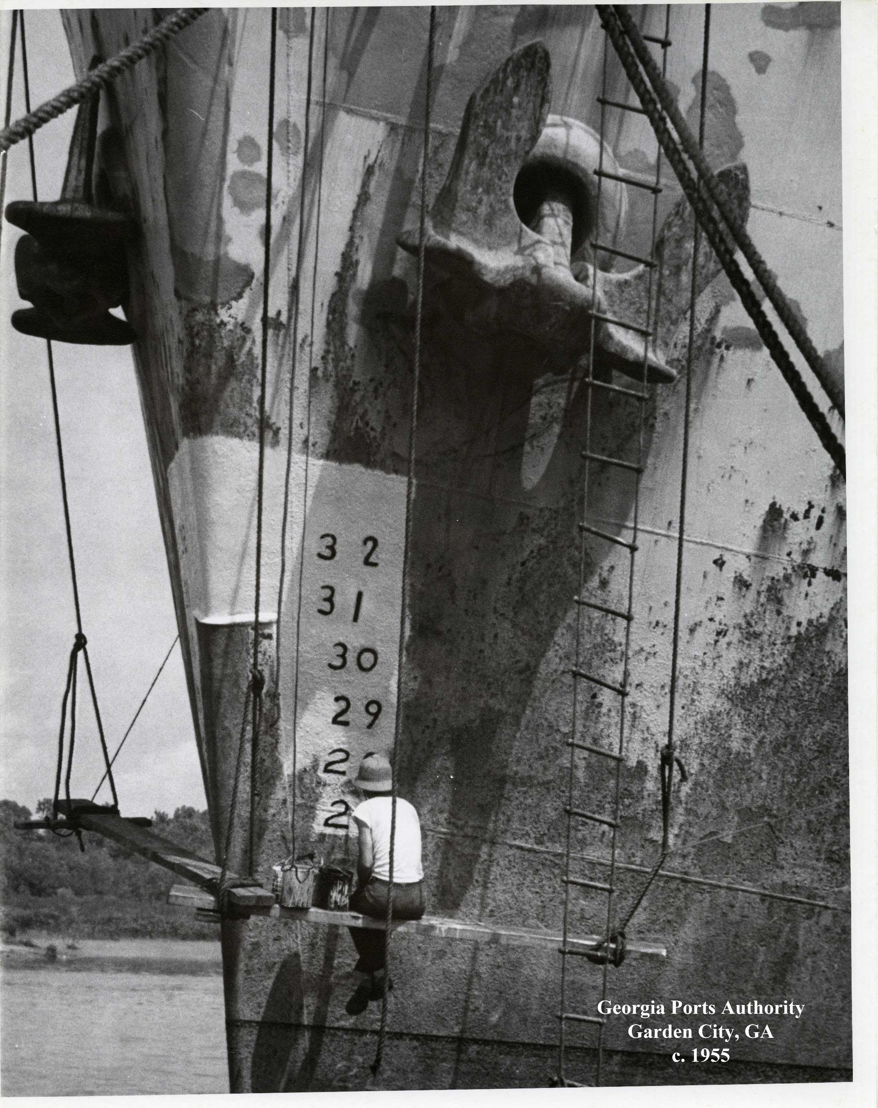
Above the
Water Line
A photographic history of
Georgia’s Ports

SUMMARY
This coffee table style book of historic port images illustrates the economic impact of Georgia’s ports beginning in the 1800s. It is a beautiful representation of the history of the Ports of Savannah and Brunswick.
It was created in partnership with the Georgia Historical Society and is made up of images dated as early as 1870, all the way through the 1960s. An introduction from the president and CEO of the Georgia Historical Society gives a brief written history of the Ports of Savannah and Brunswick while a section titled “About the Images” written by GHS’ director of research explains the origins of the images themselves.
1) CHALLENGES & OPPORTUNITIES
The request that prompted this book, was to create a gift that would have visual impact, something customers and stakeholders would want to keep on their desk or shelf.
Compared to the numbers and business focused messaging the Corporate Communications team is tasked with on a daily basis, this project presented a fun departure which was a challenge in itself.
The team wanted to create a product that represented the history and beauty of the port, something that stakeholders, customers and neighbors would be proud to display and share.
2) GEORGIA PORTS MISSION
The mission of the Georgia Ports Authority is to empower entrepreneurs, strengthen industries, sustain communities and fortify families by relentlessly striving to accelerate global commerce.
This project plays a supporting role in achieving the GPA’s mission. It is another opportunity to remind stakeholders, and people who may see this book in their offices of the opportunities available to them via the Ports of Savannah and Brunswick. It acts as a thank you to current supporters as well as a conversation starter for potential clients.
3) PLANNING & PROGRAMMING
Goal: To remind stakeholders, current customers, elected officials and potential customers about the business opportunity available to them through Georgia’s historic deepwater ports while highlighting its long history as a hub for global commerce.
Objectives:
-To create a visually appealing product that people would be happy to pursue at events, receive as gifts, and display around their offices.
-To support a strong partnership with the Georgia Historical Society.
Primary Audiences:
Current and potential port customers
Local and regional stakeholders and government leaders
Secondary Audience:
The Savannah area community

4) ACTIONS & OUTPUTS
Strategy
GPA’s strategy is to highlight the historic beauty of the Ports of Savannah and Brunswick while sharing their importance to trade through recent history. GPA partnered with the Georgia Historical Society to curate the images in the book as well as a letter in the front from the president and CEO of the Georgia Historical Society.
Tactics
Research
The first step in creating this book was to work closely with the Georgia Historical Society to choose port images from their archives. The communications team and a team from the historical society talked about what type of images would be appropriate to appear as a group. The team focused on finding more than 100-year-old images because of their rarity, along with images that were newly donated to the society from family collections and never published before.
Selection
The GHS provided Georgia Ports with about a hundred images to choose from for publication in this book. The communications team and other stakeholders met to go over the images and talk about the strength and weaknesses of each image individually as well as how they worked. The team focused on choosing images that showed people working at the ports, specific commodities that were popular during different time periods, as well as images that showed historic Savannah and Brunswick along with the port. The goal was to piece together a comprehensive photo history.
Photos
The images are reproduced from GHS archives and are located in collections of business records, books, pamphlets as well as personal and family papers and albums at GHS. Also included are commercial images taken by local photographers Foltz Photography Studio and images published on post cards. The images range in date from 1792 to the 1960s. One highlight is the official commission signed in 1792 by George Washington and Secretary of State Thomas Jefferson.
Copy
Because of the partnership with the Georgia Historical Society on this project GPA asked their president and CEO to write an introduction and the director of the GHS research center to write an “About the Images” section. The director personally located most of the images in the GHS archives for this publication so her ability to put the images in context was invaluable. The introduction from the president and CEO includes a brief written history of the organized ports in both Savannah and Brunswick.
Design
The team designed the project in-house, focusing on grouping images together that complemented each other on each page. A black and white theme was chosen in order to keep the focus of the publication on the images.

5) OUTCOMES & EVALUATION
Goal: To remind stakeholders, current customers, elected officials and potential customers about the business opportunity available to them through Georgia’s historic deepwater ports while highlighting its long history as a hub for global commerce.
Objectives:
To create a visually appealing product that would engage people at events, enjoy as gifts, and display around their offices.
Result:
GPA held a drawing for a copy of this book during the 2017 State of the Port event and more than 100 people entered. Executives frequently request copies to use for gifts to visiting VIPs. About 25 images used in the publication were also enlarged used to decorate GPA’s executive conference room.
Objective:
To support a strong partnership with the Georgia Historical Society
Result:
The project was deemed a success by the leadership of both the Georgia Historical Society and the Georgia Ports.
Anecdotal feedback from those at GPA who gift these books has been that they are very well received and VIPs normally spend some time pursuing them. Feedback from those who receive the book is also positive.

